VECTORS

SCALAR QUANTITIES - have magnitude or size only.

e.g. mass, distance, speed, density, temperature.

VECTOR QUANTITIES - have magnitude and direction.

e.g. displacement, velocity, acceleration, force, impulse, momentum.

Vectors are represented by arrows - the length indicates the magnitude of the vector and the arrowhead indicates the direction in which it acts.

i.e.
The length gives the magnitude.
This is its direction.

COMBINING VECTORS

ADDITION

Vectors are added head-to-tail. The resultant vector runs from the tail of the
first vector to the head of the last vector.

1. ADDITION

ONE-DIMENSION
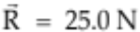
10.0 N
15.0 N

The resultant vector R = 25 .0 N - it runs from the tail of the first vector to the head
of the last vector.

TWO DIMENSIONS

VECTORS AT RIGHT ANGLES

Use Pythagorus' Theorem and trigonometry to find the resultant.
10.0 N
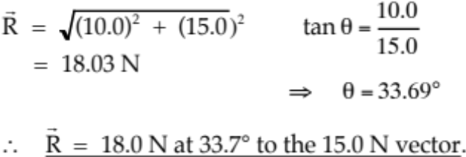

15.0 N
θ

VECTORS NOT AT RIGHT ANGLES

Use the sine and cosine rules for triangles to find the resultant vector.

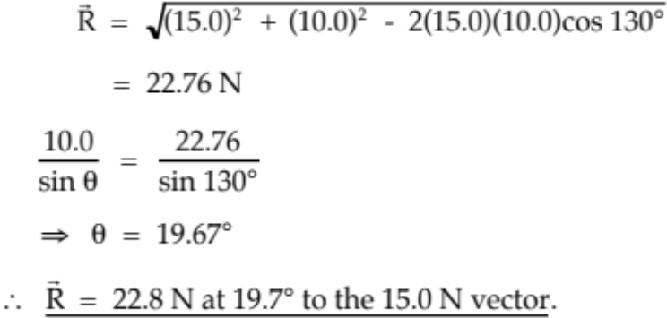
15.0 N
θ
10.0 N
130°

NOTE
If compass directions are given, it makes it easier to describe the direction.

Consider the example above.

10.0 N

N
E
130°
θ
W
S

The resultant vector R is at a 19.7° angle east of north.

∴ Direction is N 19.7° E.

Also, north can be considered the 0° bearing, with all other bearings determined clockwise from this direction.

∴ Direction is a bearing of 19.7°.

Hence R = 22.8 N N 19.7° E or R = 22.8 N on a bearing of 19.7°.

2. SUBTRACTION

ONE-DIMENSION

The easiest way to deal with vectors in one dimension is to choose one direction as positive.

Any vector in this direction is positive while all those in the other direction are negative.

It is then a simple matter of adding numbers.

EXAMPLE 1
A car moving at 15.0 ms⁻¹ brakes suddenly to avoid a dog and reduces to a velocity of
5.00 ms⁻¹. Calculate its change in velocity.

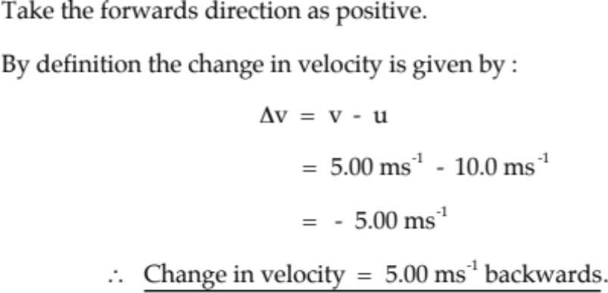

The answer is negative which means the resultant is in the opposite direction to the one you chose as positive.

i.e. The direction is backwards.

EXAMPLE 2
A ball falls onto a concrete floor at 10.0 ms⁻¹ and rebounds at 5.00 ms⁻¹. Calculate the change in velocity of the ball.
u = -10.0 ms⁻¹ since it is down in the negative direction.
5.00 ms⁻¹
Take up as positive.

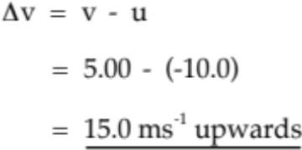
10.0 ms⁻¹

Answer is positive so the final direction is upwards in the positive direction chosen.

2. TWO DIMENSIONS

When subtracting vectors, the "negative" sign means:
"change the direction of the subtracted vector 180° and add it to the
other vector".

This works best when vectors act at an angle to each other.

EXAMPLE
A car moving at 20.0 ms⁻¹ north makes a left hand turn around a sweeping bend and heads west at 15.0 ms⁻¹. Calculate its change in velocity.

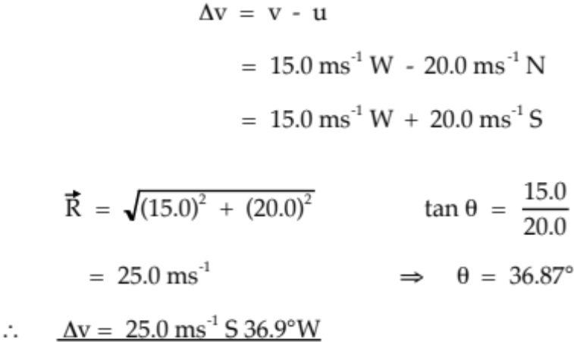

W
E

θ
N
20.0 ms⁻¹

15.0 ms⁻¹
S

The use of a compass grid line makes it easier to determine the direction of the resultant vector.

COMPONENTS OF A VECTOR

Any single vector can be expressed as two component vectors that are at right angles to each other.

Neither component vector can be bigger than the original vector.

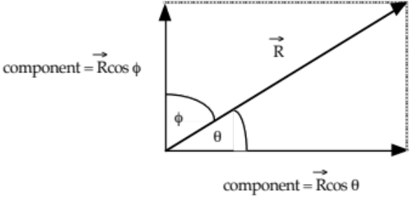

Any component is given by:
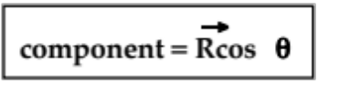

where R = given vector.
θ = the angle between R and the direction of the required component.

Examples

1. Inclined Plane

A box weighing 80.0 N sits at rest on a plane inclined at 27.0° to the horizontal.

(a) Draw a diagram showing all forces acting on the box.
(b) Calculate the force exerted perpendicular to the plane by the box onto the plane.

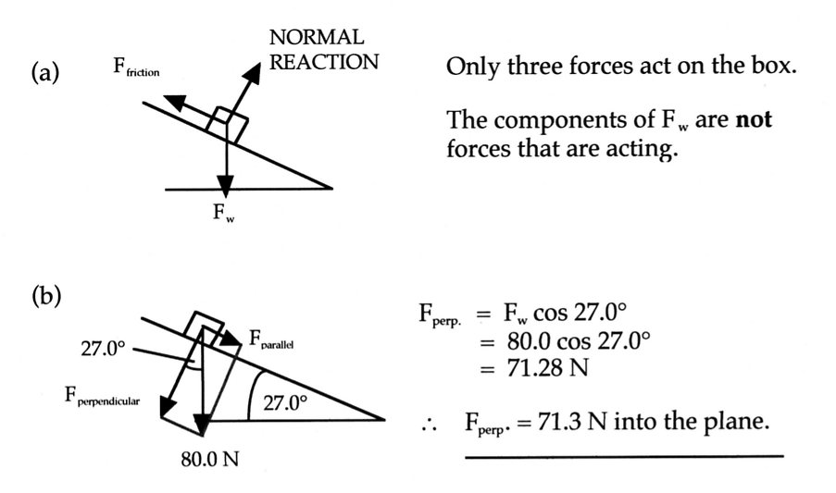
2.
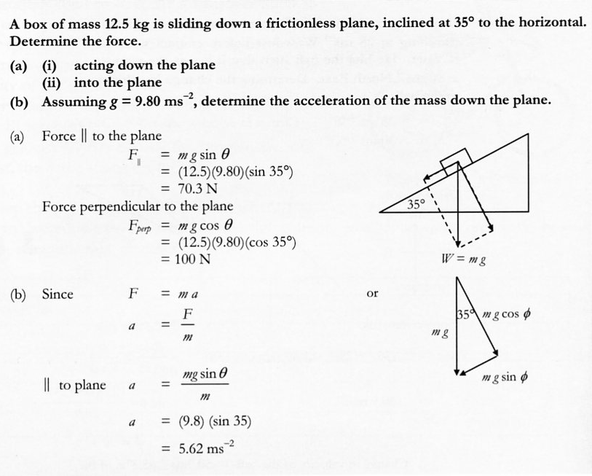
3. River Problem

A person wants to cross a river 8.00 x 10² m wide to reach a jetty directly across on the opposite bank. If the river is flowing at 6.00 ms⁻¹ and the boat that is used can travel at 15.0 ms⁻¹ in still water, calculate:

(a) the resultant velocity of the boat in relation to the river bottom (or bank).
(b) the time taken to reach the other side.
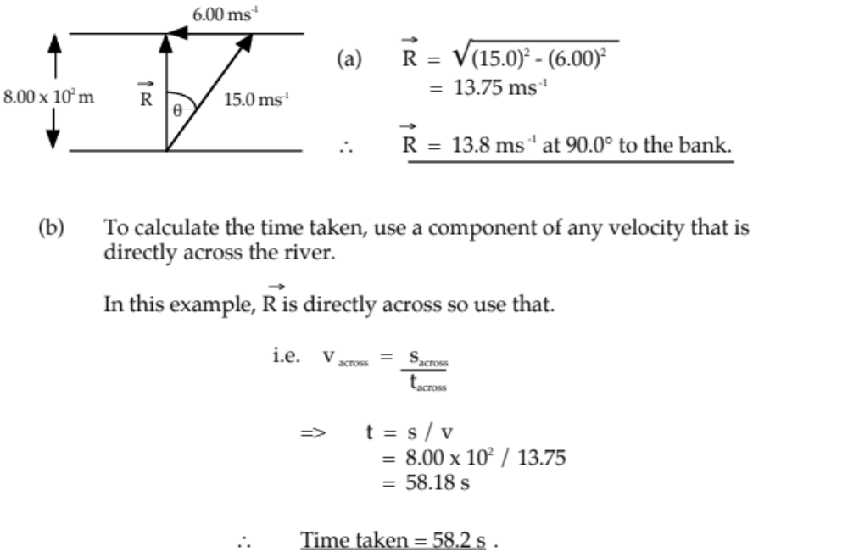

4. If the person in Question 3 was trying to reach a jetty 2.00 x 10² m upstream, calculate the resultant velocity and the time taken.

